Tworzenie projektu

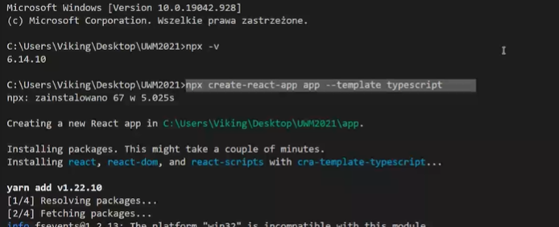

Yarn lub npm

Cd nazwa_apki

Yarn start - uruchomienie apki

Paczki dorzucone

"@material-ui/core": "^4.9.12",

"@material-ui/icons": "^4.9.1",

"@types/react-redux": "^7.1.8",

"@types/react-router": "^5.1.7",

"@types/react-router-dom": "^5.1.5",

"react-redux": "^7.2.0",

"react-router-dom": "^5.1.2",

"redux": "^4.0.5",

Linki do ccsa

<link rel="stylesheet" href="https://fonts.googleapis.com/css?family=Roboto:300,400,500,700&display=swap" />

<link rel="stylesheet" href="https://fonts.googleapis.com/icon?family=Material+Icons" />

Yarn –instalacja yarna

Tworzymy nowy folder components w nim plik CustomHeader.tsx i wrzucamy nasz Header

Export default CustomHeader

Hook UseState

